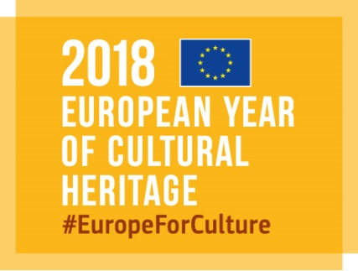

Selection of photos from winners of the EU Prize for Cultural Heritage / Europa Nostra Awards
Courtesy of Europa Nostra

In 2015, together with the Delegation of the EU to Norway, Europa Nostra organised a photo exhibition with a selection of 15 heritage accomplishments from 15 European countries which received a Grand Prix in the past five years.

Please find here the posters and roll up banner created for this exhibition.
​
The layout of the posters is in line with the visual identity of the Awards publication and could give inspiration to your graphic designer.​

Photos in high resolution
​
Europa Nostra has an extended archive of photos in high resolution of all Award winners from 2008 to 2017 on Flickr, which can easily be downloaded.​

Below the direct links to access the photos of the winners of these editions:

2017 | 2016 | 2015 | 2014 | 2013 | 2012 | 2011 | 2010 | 2009 | 2008
Download Instructions:
1. Click on the photo
2. Go to the right corner and click on the download symbol
3. Click on ‘view all sizes’
4. Click on ‘original’ and then ‘download the original size of this photo’
​
Please ensure that you mention the captions and photo credits as noted in the description field.​
​​
Download a full album:
1. You need to be logged in with a Yahoo account
2. Go to Albums, second tab after Photostream
3. Choose the album. For example: https://www.flickr.com/photos/europanostra/sets/72157681416179225
4. Click on the Download symbol under the title and description of the album

Information on each winner
On the Awards website, you can easily find information about the Awards scheme and each winner. You can also search by year, country, category and type of award.
I suggest that you select the projects that you consider most representative, according to the theme and objectives of your exhibition, and then download the relevant photos from Flickr.

Logos
Please find enclosed the logos of Europa Nostra and the EU Creative Europe programme, which should be displayed on all the posters and promotional material related to the exhibition.

We kindly ask you to inform us which projects are you planning to include in the exhibition and
send to us in advance the layout of the posters for our possible input.

